

BRAIN TEASER

Thanks for purchasing the asset , for any query of help contact me on [madfireongames@gamil.com](mailto:madfireongames@gamil.com).

Brain Teaser is a simple 2D game , it’s a complete game with ads implementation , google play services etc.

The game contain 4 scene –

1) Asset scene – it’s not important you can ignore it.

2) Main Menu scene – it’s the main menu of the game.

3) GamePlay scene – it’s the game scene.

4) ModeSelector scene – it’s the scene which decide which mode to play.

MainMenuScene

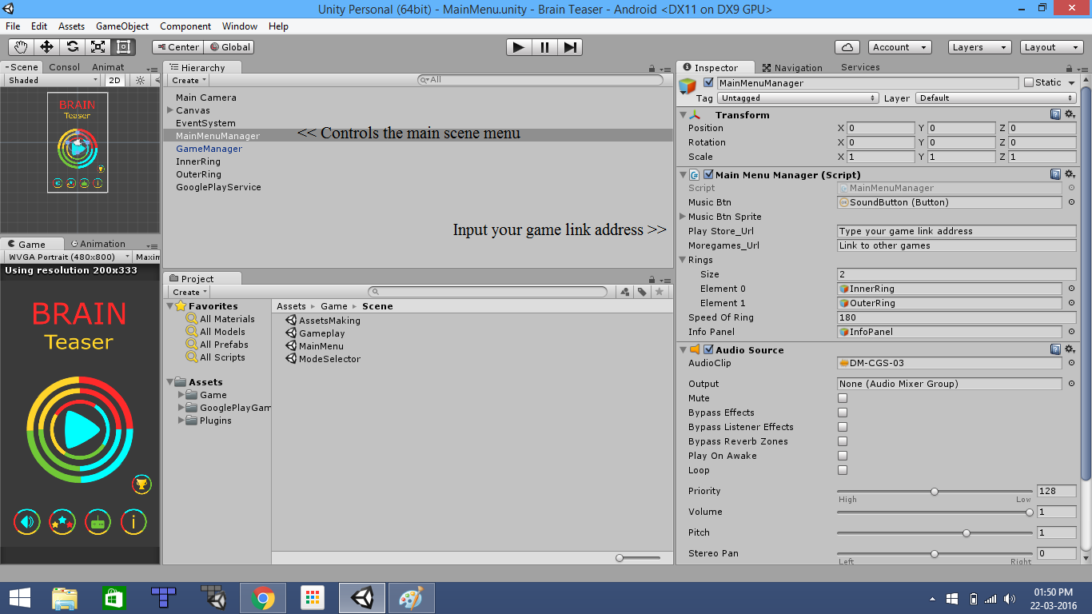

Main Menus scene contains MainMenuManager , GameManager , GooglePlayService.

Main Menu Manager controls the menu GUI.

GameManager controls the game from start to ends it’s a singleton it don not get destroyed when we move from one scene to other.

GooglePlayService controls the play services , now only leaderboard is implemented you can implement achievements also.

GamePlay Scene

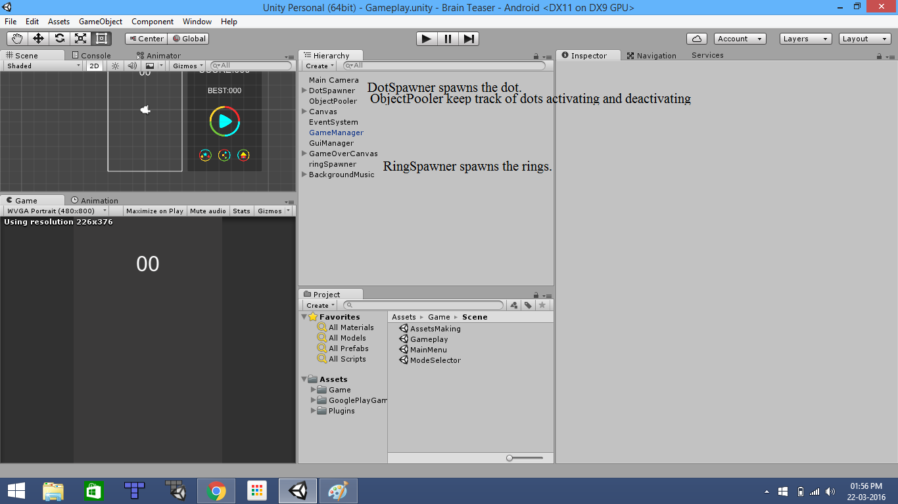

It contains DotSpawner , objectpooler , ringspawner.

ObjectPooler manages the number of dots to spawn , it spawns the all the dots and supply them as per requirement.

DotSpawner take the dots from the object pooler and make the active in the scene.

Ringe spawner spawns the rings.

GameManager

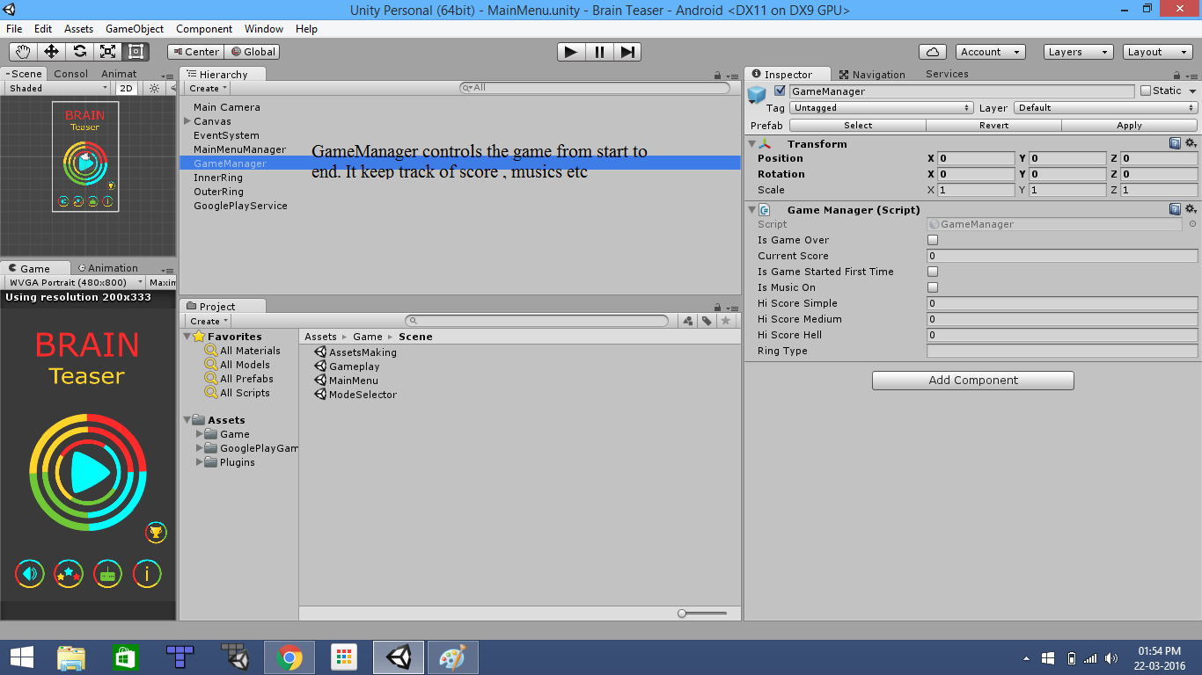

GameManager is a singleton it can’t be destroyed when we move from one scene to other. It keep track of the score and save the hi score on the devices , it keep the track of music state , etc.

DotSpawner

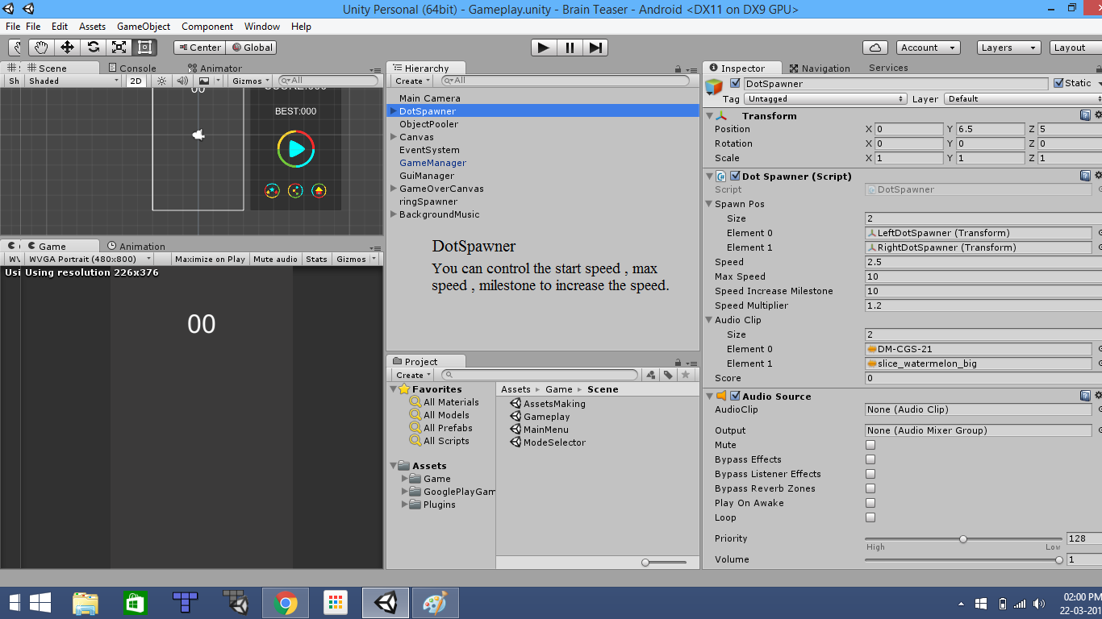

DotSpawner spawn the dots you can set the starting speed , the mile stone to increase speed , the multiplier by which the speed is increase and the maximum speed.

Important Note:- Drag the GooglePlayGames and Plugins folder outside the Complete Game folder for play service to work or else you will get error in console.

If error continues just delete the googleplaygames and plugin folder and import google play service asset.

For any help contact me.

Thanks again for purchasing the asset do rate the asset and give reviews , and please tell if any improvement is required or any addition is needed . Mail me at madfireongames@gamil.com